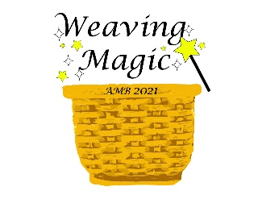
VENDOR APPLICATION
AMB Convention - October 20-24, 2021

Please Print or Type: AMB Status: Business/Cottage___ Guild ___ 2021 Teacher ___

Business Name_________________________________________________Membership #_____________

Address________________________________________________________________________________

Phone________________________Email_____________________________________________________
- A single traditional vending booth includes an 8’ X 8' space, 1 table and 2 chairs.
- Traditional vending space will be available on a first-come, first served basis.
- Traditional vendors will be placed for the public to easily access.
- Tables for Teacher vendors will be on a first come, first served basis. You are strongly encouraged to apply early.
- Teacher vendor tables will be around the perimeter of the room and may not be close to teaching area (we will try to do our best to make it close).
- Rooms will be locked when not in use. No security is provided.
- There will be community trash cans.
- Wi-Fi available at no cost.
Due August 15 – Apply Early | Number Ordered | Cost Each | Total Cost
Traditional Vending
8' X 8' Space (1 table and 2 chairs) |  | $30.00
Extra table |  | $15.00
Teacher Vendor
1st table |  | $15.00
2nd table |  | $20.00
Electric Hookup (Special drop) |  | $25.00
Logo Use |  | $25.00
Late Fee - If after 8/15/2021 |  | $10.00
TOTAL AMOUNT ENCLOSED

List the items you will be selling (must be basket related):__________________________________________
______________________________________________________________________

Indicate names for nametags:_________________________________________________________________
______________________________________________________________________
Please read and sign: I understand I am responsible for insurance coverage and will not hold the AMB or the Plaza-Grand Rapids responsible for any damage or loss incurred. I understand the doors will be locked Tuesday evening through Sunday during the hours the classrooms are not in use. I understand that I must pay Michigan sales tax and file the appropriate forms (Michigan tax forms will be available).

Signature:____________________________________________________Date:______________________

Enclose a check for the total amount made out to AMB.
No refunds after September 15, 2021, unless space can be sold.
QUESTIONS CONTACT: Sarah Nestle Phone: 989-854-1363
8440 S. Loomis Rd.
Shepherd, MI 48883-8003 sarah@basketsbyhand.com

